
Touchstones Project
Netcards

Joy Netcards with Text

Broken HRJ
Child with Book HRJ
Children HRJ
Dancing HRJ

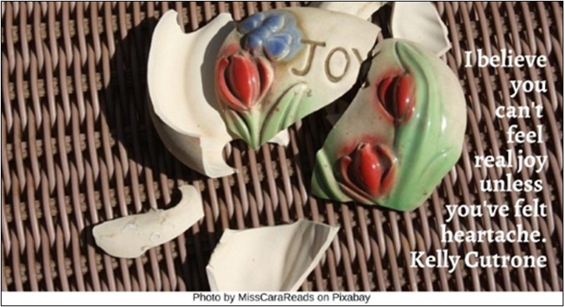

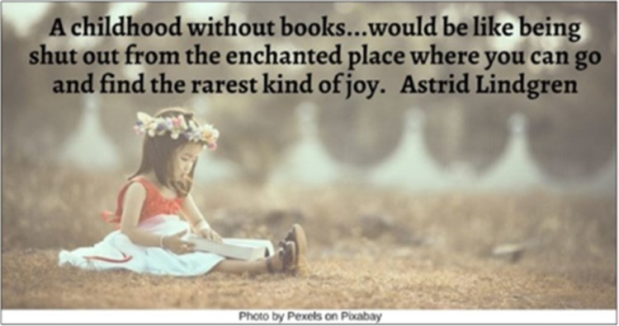

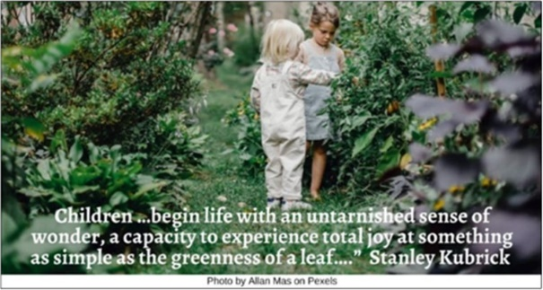

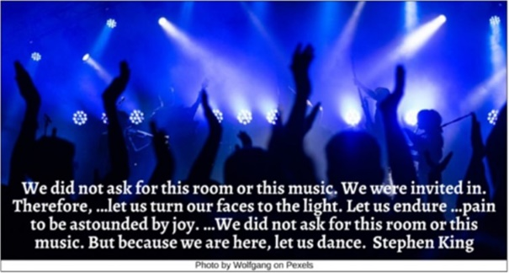

Dawn HRJ
Depression HRJ
Dog HRJ
Dreams HRJ

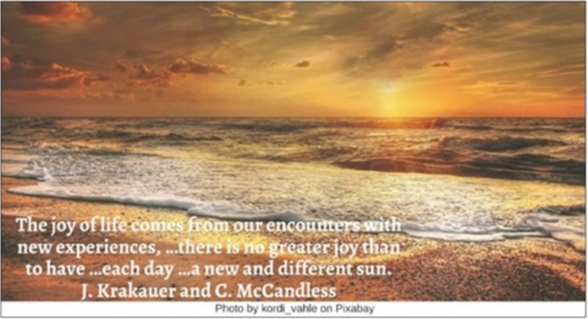



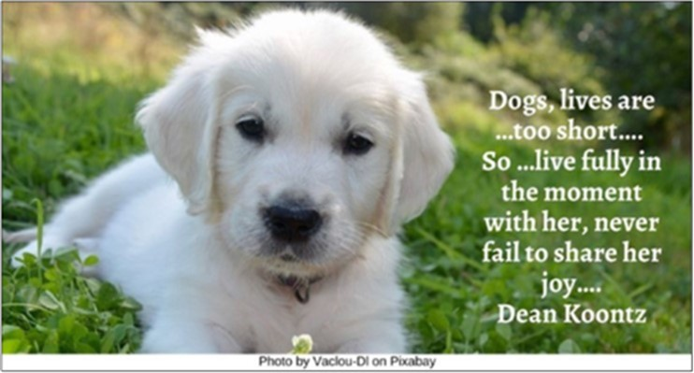

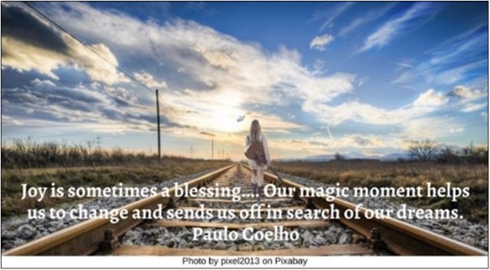

Family HRJ
Flowers HRJ
Grave HRJ
Irish HRJ

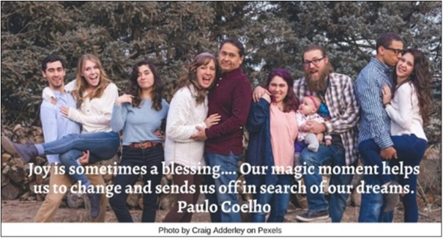

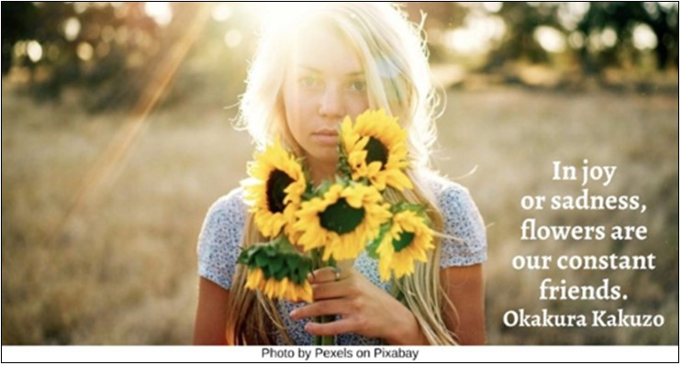

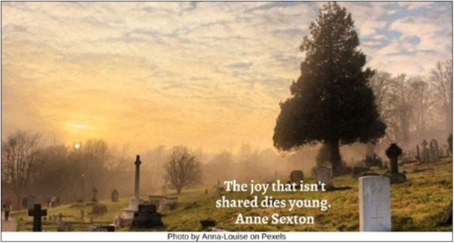

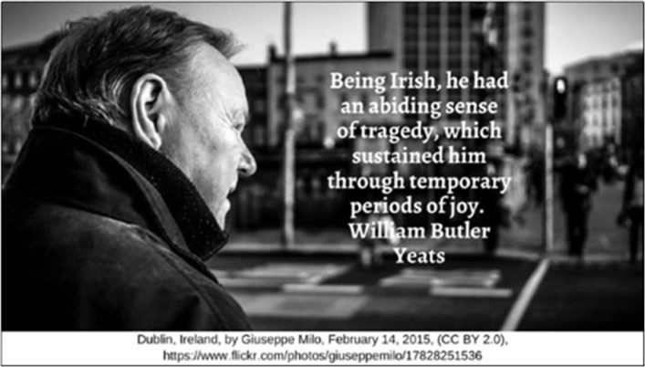

Love HRJ
Meditation HRJ
Monet Painting HRJ
Nets HRJ



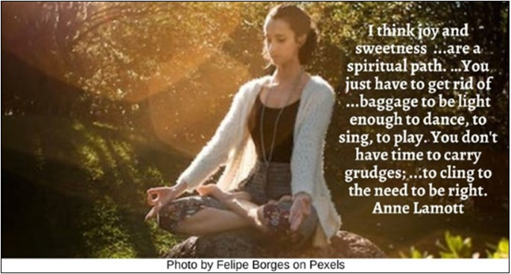

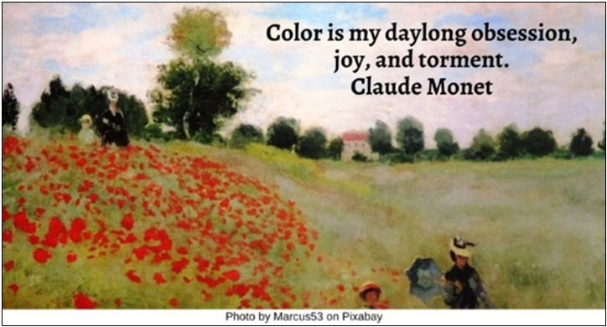

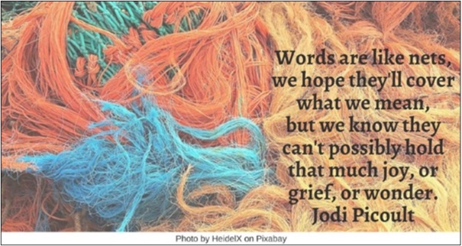

One-of-a-Kind HRJ
Puddle HRJ
River HRJ
Rocky Shore HRJ



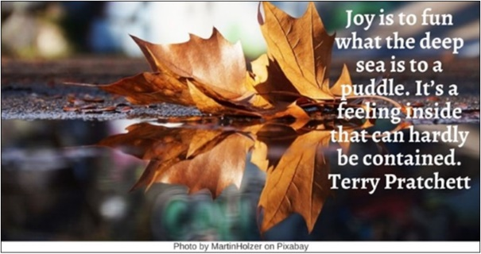

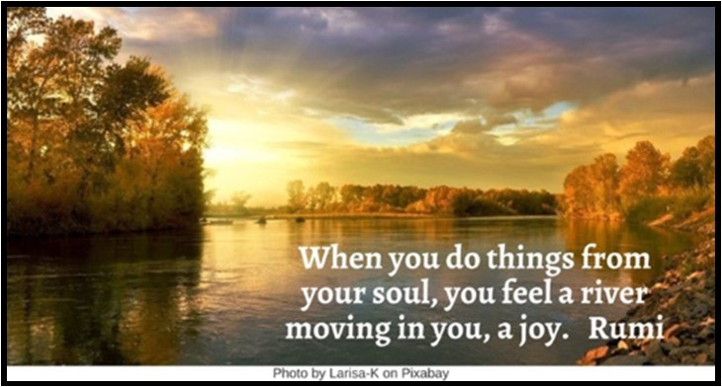

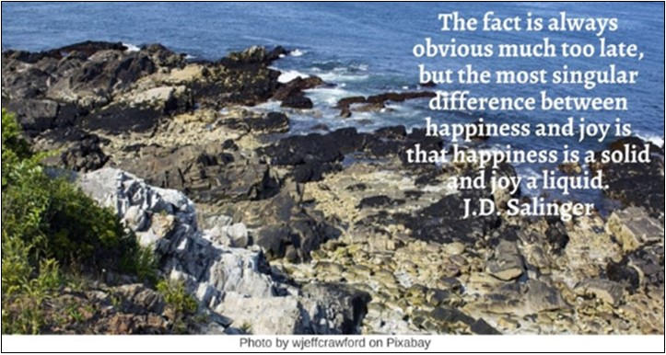

Rose HRJ
Salvador Dalí HRJ
Shadows HRJ
Shooting Star HRJ

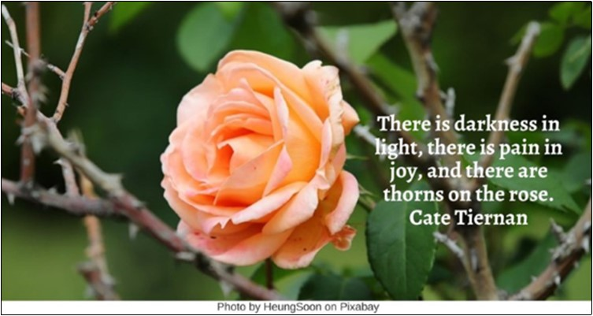

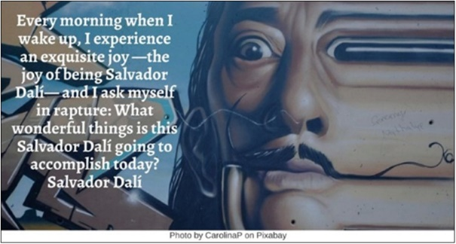

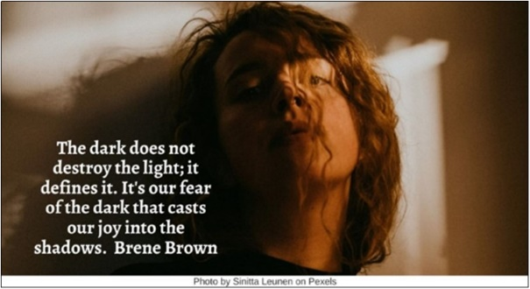

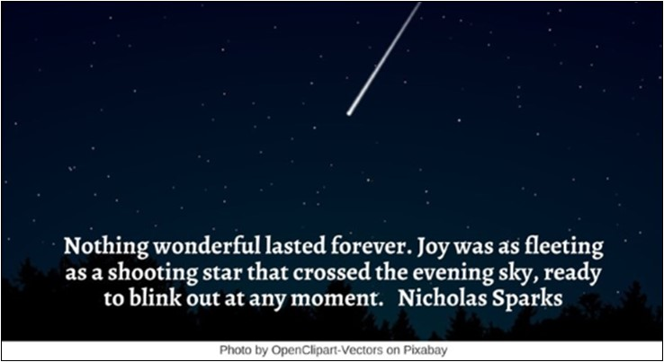

Smile HRJ
Teacher HRJ
Tears HRJ
Two Seconds HRJ



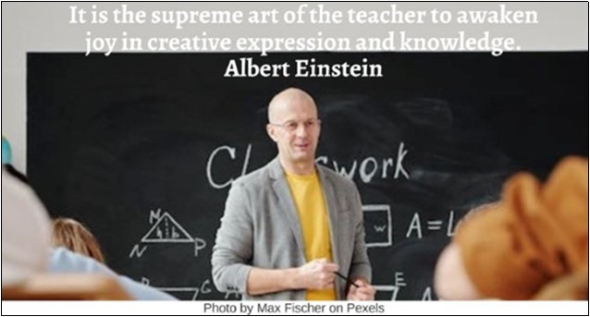

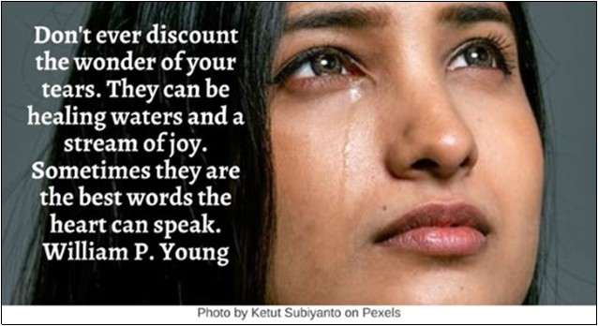

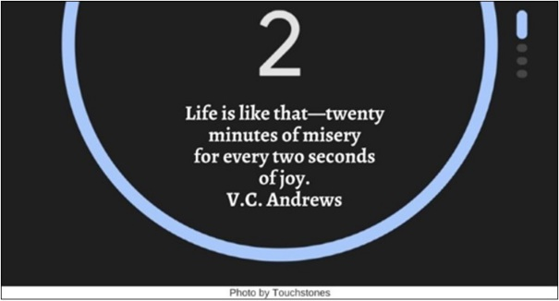

Wine HRJ
Winter Dusk HRJ
Woman HRJ

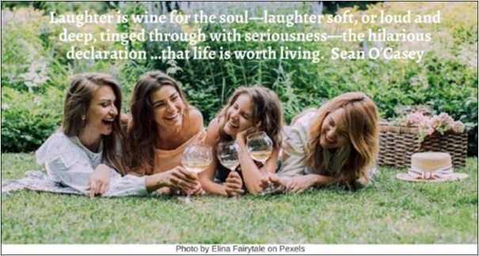

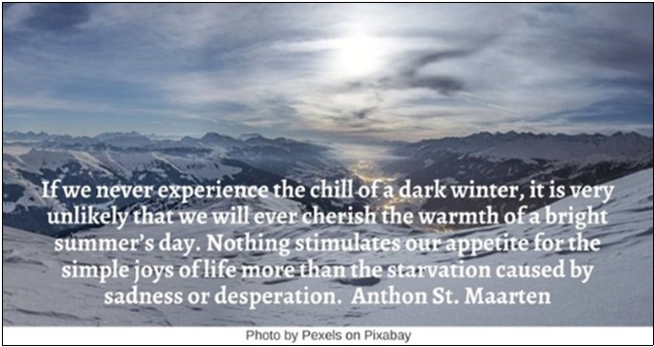



Text of Quotes
Broken HRJ
I believe you can't feel real joy unless you've felt heartache. Kelly Cutrone

Child with Book HRJ
A childhood without books—that would be no childhood. That would be like being shut out from the enchanted place where you can go and find the rarest kind of joy. Astrid Lindgren

Children HRJ
Children …begin life with an untarnished sense of wonder, a capacity to experience total joy at something as simple as the greenness of a leaf….” Stanley Kubrick

Dancing HRJ
We did not ask for this room or this music. We were invited in. Therefore, …let us turn our faces to the light. Let us endure …pain to be astounded by joy. …We did not ask for this room or this music. But because we are here, let us dance. Stephen King

Dawn HRJ
The joy of life comes from our encounters with new experiences, …there is no greater joy than to have …each day …a new and different sun. J. Krakauer and C. McCandless

Depression HRJ
They flank me—depression on my left, loneliness on my right. …They empty my pockets of any joy I had been carrying there. Depression even confiscates my identity…. Elizabeth Gilbert

Dog HRJ
Dogs, lives are …too short…. …So …live fully in the moment with her, never fail to share her joy…. Dean Koontz

Dreams HRJ
Joy is sometimes a blessing…. Our magic moment helps us to change and sends us off in search of our dreams. Paulo Coelho

Family HRJ
The great joy and honor of my life has been to know you. To call you my family. And I am grateful—more than I can possibly say—that I was given this time with you all. Sarah J. Maas

Flowers HRJ
In joy or sadness, flowers are our constant friends. Okakura Kakuzo

Grave HRJ
The joy that isn't shared dies young. Anne Sexton

Irish HRJ
Being Irish, he had an abiding sense of tragedy, which sustained him through temporary periods of joy. William Butler Yeats

Love HRJ
Love is an invisible connection that is exquisitely felt by those who know the joy, feel the warmth, share the sweetness, and celebrate the gift! Douglas Pagels

Meditation HRJ
I think joy and sweetness ...are a spiritual path. …You just have to get rid of ...baggage to be light enough to dance, to sing, to play. You don't have time to carry grudges; ...to cling to the need to be right.
Anne Lamott

Monet Painting HRJ
Color is my daylong obsession, joy, and torment. Claude Monet

Nets HRJ
Words are like nets—we hope they'll cover what we mean, but we know they can't possibly hold that much joy, or grief, or wonder. Jodi Picoult

One-of-a-Kind HRJ
Tell the world you are one-of-a-kind creation who came here to experience wonder and spread joy. Expect to be accommodated. Victoria Moran

Puddle HRJ
Joy is to fun what the deep sea is to a puddle. It’s a feeling inside that can hardly be contained. Terry Pratchett

River HRJ
When you do things from your soul, you feel a river moving in you, a joy. Rumi

Rocky Shore HRJ
The fact is always obvious much too late, but the most singular difference between happiness and joy is that happiness is a solid and joy a liquid. J.D. Salinger

Rose HRJ
There is darkness in light, there is pain in joy, and there are thorns on the rose. Cate Tiernan

Salvador Dalí HRJ
Every morning when I wake up, I experience an exquisite joy —the joy of being Salvador Dalí— and I ask myself in rapture: What wonderful things is this Salvador Dalí going to accomplish today? Salvador Dalí

Shadows HRJ
The dark does not destroy the light; it defines it. It's our fear of the dark that casts our joy into the shadows. Brene Brown

Shooting Star HRJ
Nothing wonderful lasted forever. Joy was as fleeting as a shooting star that crossed the evening sky, ready to blink out at any moment. Nicholas Sparks

Smile HRJ
Sometimes your joy is the source of your smile, but sometimes your smile can be the source of your joy. Thích Nhất Hạnh

Teacher HRJ
It is the supreme art of the teacher to awaken joy in creative expression and knowledge. Albert Einstein

Tears HRJ
Don't ever discount the wonder of your tears. They can be healing waters and a stream of joy. Sometimes they are the best words the heart can speak. William P. Young

Two Seconds HRJ
Life is like that—twenty minutes of misery for every two seconds of joy. V.C. Andrews

Wine HRJ
Laughter is wine for the soul—laughter soft, or loud and deep, tinged through with seriousness—the hilarious declaration …that life is worth living. Sean O'Casey

Winter Dusk HRJ
If we never experience the chill of a dark winter, it is very unlikely that we will ever cherish the warmth of a bright summer’s day. Nothing stimulates our appetite for the simple joys of life more than the starvation caused by sadness or desperation. Anthon St. Maarten

Woman HRJ
Joy is the best makeup. Anne Lamott

